PHASE 4
Business Rule, Security & Validation

1. Objective
Enforce the one-request-per-year policy at the backend and control access using roles, groups and ACLs.

2. Duplicate Request Business Rule
Business Rule Name: Laptop request BR. Table: Laptop Request Form. Run: Before Insert. Advanced: Enabled.
- Navigate to All > System Definition > Business Rules.
- Click New.
- Name the rule Laptop request BR.
- Select Laptop Request Form as the table.
- Enable Advanced.
- Set When to run: Before.
- Enable Insert.
- Add the validation script that checks the requester for an existing request in the current calendar year.
- If a duplicate exists, block insertion and display an error message.

3. Business Logic
- When a new request is submitted, identify the requester.
- Check existing laptop requests for the current calendar year.
- If a matching request exists, prevent the new record from being created.
- Display a clear duplicate-request error to the employee.
Business Rule configuration and duplicate validation result.
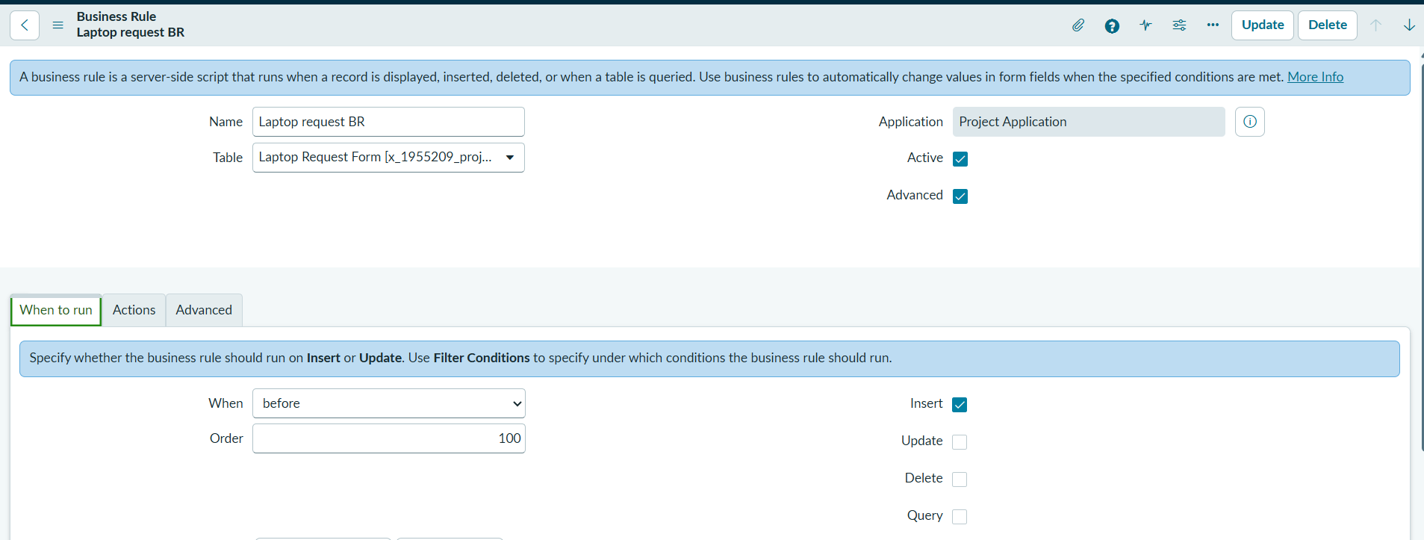
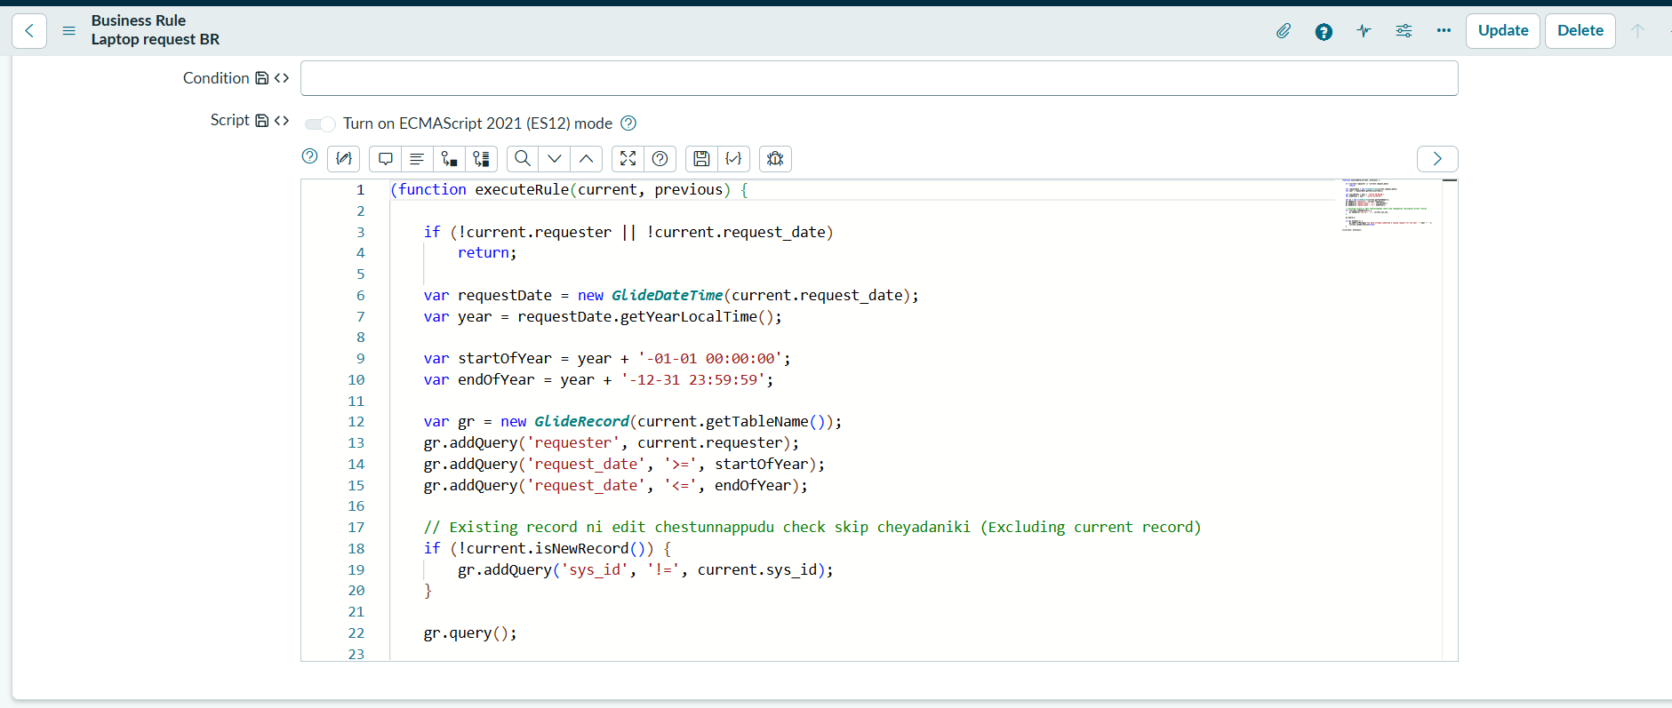
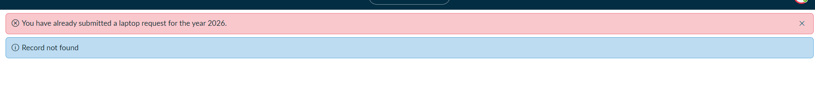

4. Role Creation
Role | Purpose
it_manager | View-only access for managers
it_employee | Create and manage laptop requests
- Navigate to All > User Administration / Users and Groups > Roles.
- Click New.
- Create it_manager and it_employee roles.

5. Group Creation & User Mapping
Group | Role | Members
IT Managers | it_manager | 8 users
IT Employees | it_employee | 10 users
Assign users to the appropriate group and assign the corresponding role to each group.

groups, members and assigned roles.
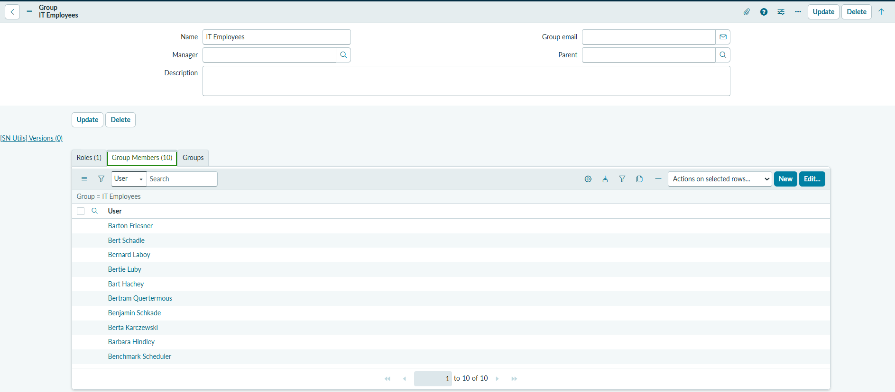
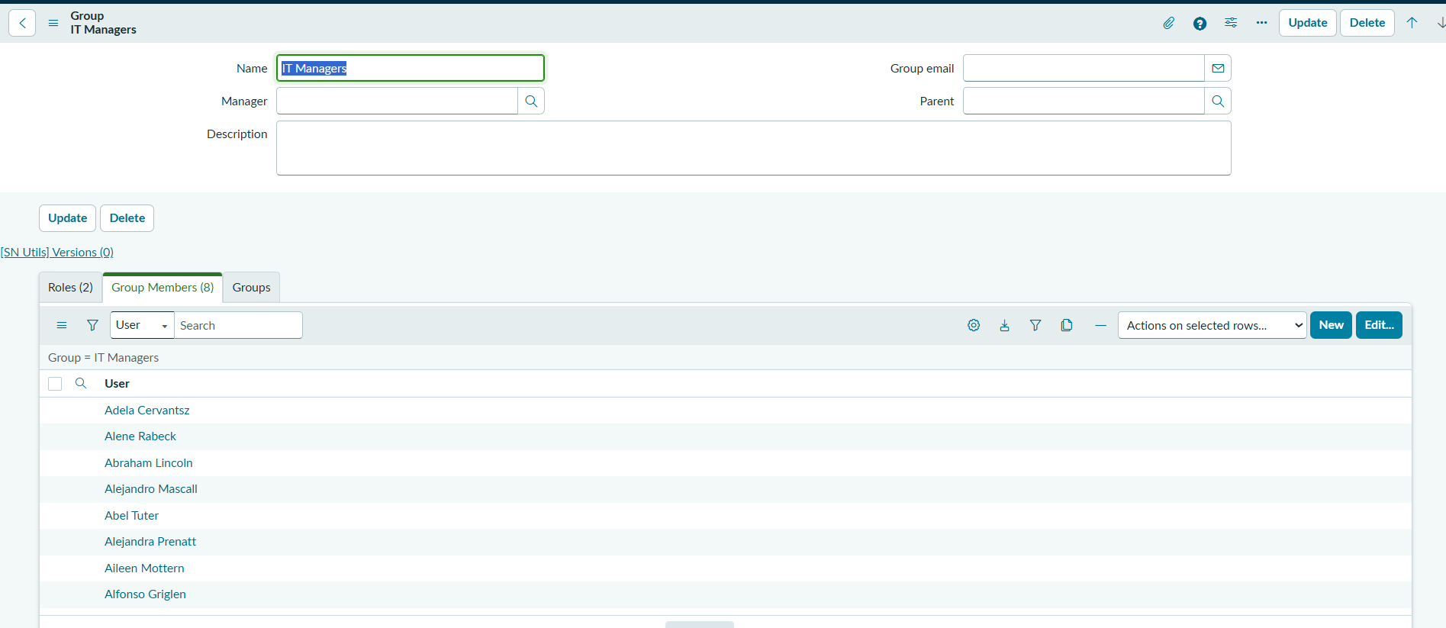

6. ACL Configuration
Use table-level ACLs (tablename.none) to provide consistent access control.
Role | Operation | Expected Access
it_manager | Read | View laptop request records
it_employee | Create | Create laptop requests
it_employee | Read | View requests and status
it_employee | Write | Modify permitted request records
- Enable the required elevated administrative role before creating ACLs.
- Navigate to All > System Security > Access Control (ACL).
- Create a Read ACL for Laptop Request Form with role it_manager.
- Create Create, Read and Write ACLs for Laptop Request Form with role it_employee.
- Save and test the ACLs.
Read, Create and Write ACL records.
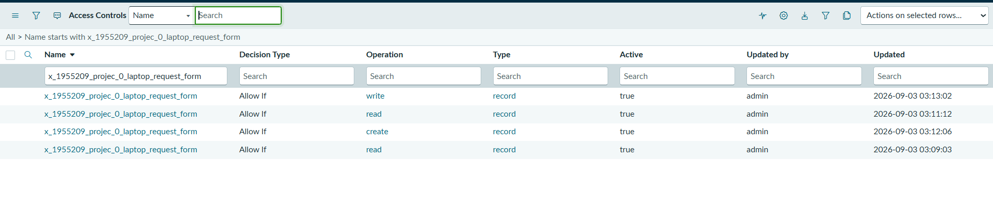

7. Security & Functional Validation
Test Scenario | Expected Result
Employee creates request | Allowed
Employee edits request | Allowed
Employee submits second request in same year | Blocked
Manager views request list | Allowed
Manager tries to edit/create | Blocked
test results / impersonation validation.
